**DAILY ONLINE ACTIVITIES SUMMARY**

|  |  |  |  |  |  |  |  |
| --- | --- | --- | --- | --- | --- | --- | --- |
| **Date:** | **22/06/20** | | | | **Name:** | **Harshitha M** | |
| **Sem & Sec** | **8th sem, A sec** | | | | **USN:** | **4AL16CS038** | |
| **Online Test Summary** | | | | | | | |
| **Subject** | | **SMS** | | | | | |
| **Max. Marks** | | **20** | | **Score** | | **Not displayed** | |
| **Certification Course Summary** | | | | | | | |
| **Course** | **Introduction to cyber security** | | | | | | |
| **Certificate Provider** | | | **Great Learning** | **Duration** | | | **5hrs** |
| **Coding Challenges** | | | | | | | |
| **Problem Statement: Java program to find string inside a string** | | | | | | | |
| **Status: Completed** | | | | | | | |
| **Uploaded the report in Github** | | | | **Yes** | | | |
| **If yes Repository name** | | | | **Harshitha-M** | | | |
| **Uploaded the report in slack** | | | | **Yes** | | | |

Certification Course Details:

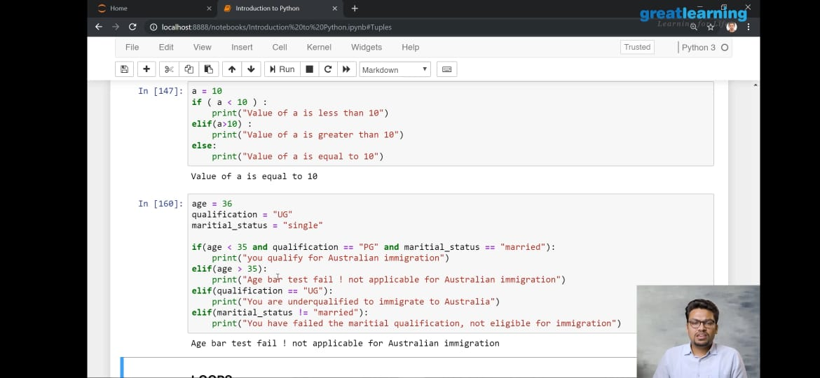

Coding Challenges Details:

public class MyClass

{

public static void main(String[] args)

{

String txt = "Please locate where 'locate' occurs!";

System.out.println(txt.indexOf("locate"));

}

}